Peter Lee

CS 3600 – Project#4b

11/29/2018

**Question 5:**

We can see that the Pen Data Set performed better in terms of the max and average accuracy with the default training hyperparameters than the Car data set and the training on the Car data set had much higher standard deviation, implying that the neural net had more or farther local optima that it converged on than the Pen data set.

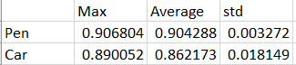

The graphs were produced from Question5.py and plotting the CSV values.

Question 6:

For the Pen data set, the maximum Accuracy over the test data set was when the Hidden layer was about 15 nodes. This shows that more hidden layers does not necessarily mean increased performance. What often happens is that the neural net over-fits the training data with too many nodes.

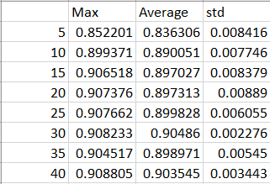

For the Car data set, the maximum Accuracy over the test data set was when the Hidden layer was about 30 nodes. Initially, we can see that increasing the hidden layer improved performance however we can see diminishing returns as we continue increasing the hidden layer size.

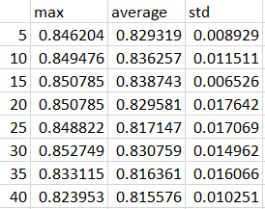

The graphs were produced from Question6.py and plotting the CSV values.

Question 7:

As we can see from my experimental data below, the minimum number of Hidden layers required was 2. Without a hidden layer, the output is always True, hence 50% accuracy on my test data set and With one logic gate, It was able to approximate an OR gate, Hence 75% accuracy. With two Hidden nodes, the neural net was finally able to approximate a XOR gate. The minimum was two because you need a minimum of 2 logic gates to create an XOR gate. The graphs were produced from Question6.py and plotting the CSV values. The results were expected as a minimum of 2 gates are before the hidden layer to produce an XOR Gate

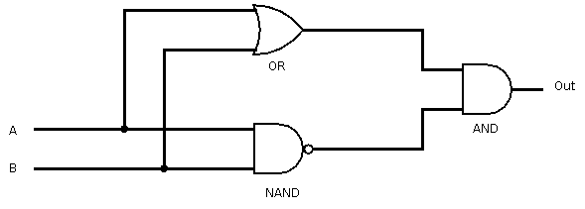

The graph were produced from Question7.py and plotting the CSV values.